Outcomes from MRSPAG Suicide Prevention Forum – 28 June 2017

About the forum
The Macedon Ranges Suicide Prevention Action Group (MRSPAG) hosted a Suicide Prevention Forum on Wednesday 28 June 2017 to explore ways the community can work together to prevent suicide in the Macedon Ranges.

More than 50 people attended to share ideas for practical actions.

The forum began with two speakers who have lived experience of suicide – MRSPAG Deputy Chair Noelene Ward shared her moving story of losing her son to suicide and Andrew Rogers spoke openly about his lived experience as a suicide attempt survivor.

Both speakers highlighted that as a society, Australia is not equipped to deal with the issue of suicide or understand the extent to which the community could support people with mental illness. Talking about suicide and suicidality can be difficult, but both speakers stressed that discussing these issues in a responsible, safe way as a community can help to prevent suicide.

MRSPAG Chair Lynsey Ward outlined what we have accomplished so far towards achieving our objectives to decrease stigma and raise community awareness; support people at risk and those bereaved by suicide; advocate for improved mental health services in the shire; and strengthen our evidence base.

Working in groups, participants then discussed ideas for how MRSPAG’s objectives might be achieved. Two MRSPAG members sat on each table to facilitate discussion and record people’s suggestions.
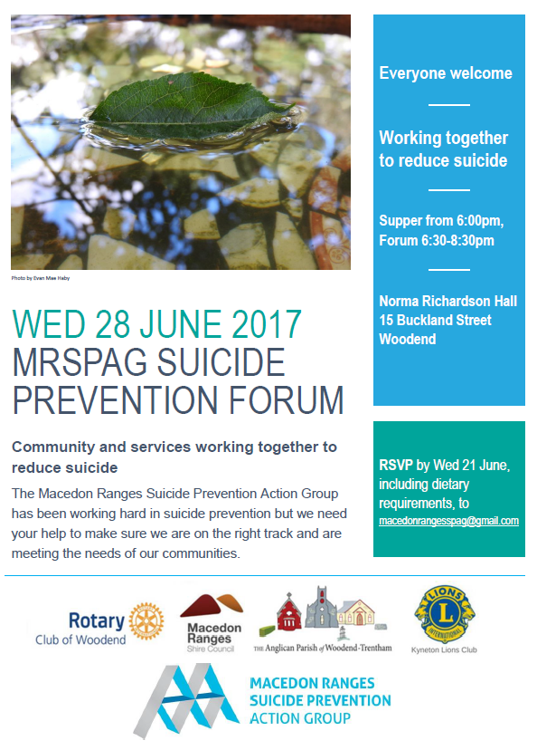
Michal Morris, a Director of North Western Melbourne Primary Health Network spoke briefly about their Macedon Ranges place-based suicide prevention initiative which is about to commence and will roll out over the next four years.

The ideas and discussions from the forum will inform MRSPAG’s action plan and future activities.

Acknowledgements
Members of MRSPAG extend thanks to community members and service providers for sharing their ideas as well as to forum facilitator Tim Adam, Woodend Rotary, Macedon Ranges Shire Council, the Anglican Parish of Woodend-Trentham, Kyneton Lions, Openhouse Macedon Ranges and Gisborne Rotary for helping make this event possible.

Forum evaluation
Method  - A pocket evaluation board was placed by the exit.  - Before the end of the forum, each participant was given 3 beads.  - They were asked to place a bead in the pocket that represented their answer to the questions written on the evaluation board.  Results  Question Yes No Unsure Total  Did you feel heard? 36 - 2 38  Are you happy with the direction of MRSPAG’s action plan? 37 - 2 39  Do you know where to get help for you or your family and friends? 31 1 5 37 | 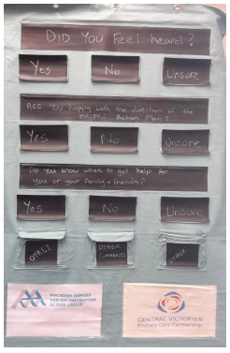
Comments
- Well done, great job MRSPAG
- Peer support Group for those in constant pain (who are suicidal)
- Clubs/community entities that receive funds from MR council be required to develop and implement a mental health plan
- OH&S to become Occupational Mental Health & Safety. Require reps to be retrained and then present to their colleagues

Summary
Approximately 75% of people who registered participated in the evaluation (between 37 and 39 of the 52 registered). Overall the feedback on the forum was extremely positive: the majority felt heard and were happy with the direction of MRSPAG’s action plan. Also the majority knew where to get help for themselves, family or friends.

Analysis of forum discussions

Method
- Notes from the night were transcribed.
- Comments from the forum were grouped into themes under each MRSPAG objective.
- Themes were turned into potential actions for MRSPAG to discuss.
- MRSPAG discussed the potential actions at our August meeting and fine-tuned the wording of actions, these are listed on the following pages

Potential actions for MRSPAG under each objective:

1: To decrease stigma and raise community awareness around suicide and suicide prevention

- Identify evidence-based resources to help people start conversations about mental health and suicide and add a list to the MRSPAG website
Comments from forum participants
- Encourage talking will reduce stigma
- Start conversations – there is power in people’s voices
- Guidelines for how you start the conversation about mental health > talking to family, friends etc.
- Educate the community about how they can talk about suicide – realistic conversations > video to demonstrate how to talk about suicide {e.g. UK video/ad} imagined response vs real response to talking about suicide with message at the end on where to get help and support
- Listening – not always a professional who can help but a friend / family member; Knowing what to look for in someone experiencing suicidal thoughts
- Holistic care for yourself > need to make sure keep people safe ‘do no harm’

- Identify evidence-based stigma busting activities; select and trial some that may suit the local context.
Comments from forum participants
Activities / campaigns
- Identify successful, evidence-based campaigns, e.g. ‘it’s not weak to speak’ in UK…with members of the Royals speaking out about mental health; appropriate to audience (age etc.); Dispel myths
- Whole of community activities, e.g. walks, that are accessible to people fearful of talking about suicide
- Breaking down stigma through art > e.g. Anglicare’s art exhibition during Mental Health week; suggestion of doing something with Daniel Butterworth a local artist and teacher who is a champion of mental health
- Learn from other stigma-busting efforts, e.g. LGBTI
- Engage with journalists (hipster mags, not mainstream) to discuss issues in a safe way to encourage help-seeking; Collate articles that are good (does Mindframe do this?)
- More forums like this will help overcome stigma
- Start reporting on the ‘suicide toll’ using the same method as the ‘road toll’? Both ‘health issues’ would this help reduce stigma?

Methods
- Use a variety of media tools, e.g. newspaper, FB, newsletter; use personal stories; key messages: talk and listen; MRSPAG should start a FB page to share articles, inspirational comments – so important to certain parts of community (SANE’s FB page very good at breaking down stigma)
- Info bags available at GP rooms, libraries, playgroups; an info table out the front of supermarkets at certain times of year e.g. Mental Health Week

- In partnership with North Western Melbourne Primary Health Network and Macedon Ranges Lived Experience Speakers Bureau, educate key people in the community about mental health and suicide prevention (don’t assume they already know)
Comments from forum participants
Key people
- Connect with GPs
- Make sure funeral directors are informed about suicide so they can help those bereaved > we need to talk about death more broadly, there is stigma around death / dying
Educate
- Promote Mental Health Plans to community and GPs (what they are and how to get one)
- Talk about symptoms of mental ill-health {through L4L, YMHFA}; could the bystander model for violence against women, bullying, and racism be adapted somehow? / Applied Suicide Intervention Skills training (ASIST); Deliver YMHFA training in primary schools / to primary school communities (parents, teachers)

- Become a Mental Health First Aid-skilled community by increasing the proportion of Macedon Ranges young people and adults trained in Mental Health First Aid to 20% by 2020 (currently 13%).
Comments from forum participants
- Training; Mental Health First Aid training (MHFA) repeatedly mentioned

Possible future actions
- MRSPAG to consider holding a Q and A style-forum in the future.
Comments from forum participants
- Holding a Q&A style session like Jenny Brockie (SBS Insight) – a facilitated public discussion about suicide and suicide prevention – with a small audience or hold a public screening of a session – or discussions via local radio with informed people > need to make sure keep people safe ‘do no harm’. People who have lived experience speak (speakers would need training and support).

- There was some discussion at the MRSPAG August meeting about an idea that emerged from the forum regarding Occupational MENTAL health and safety. Mental Health First Aid Australia has a focus on workplaces as well as community https://mhfa.com.au/mental-health-first-aid-officers. It was agreed that MRSPAG could consider this as a future focus of advocacy.

2: To identify a model for supporting people at risk

- In partnership with North Western Melbourne Primary Health Network, Macedon Ranges Health, Cobaw Community Health and PS My Family Matters, design and test a support model for people at risk that includes:
- engaging those with lived experience of suicide to co-design and/or review model ideas
- mapping current professional and community support available and how people can find out about them
- setting up a bank of volunteers to provide practical and other forms of support
- providing information for families caring for someone at risk
- outreach to people at risk
Comments from forum participants
Model elements
- Chaplain programs – who can provide support, in particular in crisis situations
- Socialisation with others in community via community groups or activities
- Drop in space for when someone is feeling vulnerable, e.g. Health Centre, Library, Neighbourhood House, where people can feel safe and seek help; with a phone available for people to call Lifeline; volunteer available for one to one support
- Advocate for financial support for those at risk
- Place financial value on help (provided by community)
- Preventative measures such as yoga, breathing, meditation, good nutrition starting at primary schools

Community volunteer register
- Community register – volunteer to phone weekly people at risk
- Volunteer visiting in the home / social outing with transport
- Volunteer bank – people who can provide support
- Practical hands on, task oriented community support that weaves a safety net

Mapping
- Mapping of what supports exist locally to tap into and share resources
- Mapping of services, community groups > what can we learn from Men’s Sheds, PS My Family Matters, HALT etc.

Information / training
- Support and education for families and family members who are supporting someone at risk
- A way to find people at risk AND a way for people at risk to find a support group
- Mental Health First Aid training in all schools
- App on phone
- Offering support / education / information on how to increase protective factors, e.g. dog walking, gardening, walking groups
- Making mental health training a condition of grant funding
- Community trained in mental health first aid
- Training of support people in mental health as community members

Lived experience
- Engage those with lived experience of suicide to design / review model ideas

3: To continue to provide peer support for people bereaved by suicide

- Develop a communications/promotion plan for the Macedon Ranges Peer Support After Suicide (PSAS) group.
Comments from forum participants
Promotion methods
- People around/connected to someone who has died need to know who to approach for practical help
- Everyone trained / increase awareness
- Advertise in newspapers, newsletters,
- Encourage people to take photos to put onto flyer
- Tear off bits on flyers for old school
- Sponsored item into homes with info/logo, e.g. coffee cup lids with sticker
- Sporting clubs – logo and info on field
- Adjuct to Live4Life
- champions within service clubs
- Sporting groups – use as a central place to communicate mental health messages

Promotion locations
- Info at chemists, GPs, Police, mental health practitioners, chaplaincy
- Info with Council rates
- Info at pet shops / vets
- GP office, community noticeboards
- Include info in new residents’ kits (from Council)?

- In partnership with Jesuit Social Services - Support After Suicide and Standby, identify who might benefit from peer support but isn’t currently engaged with the Macedon Ranges Peer Support After Suicide group.

Note: Jesuit Social Services - Support After Suicide and Standby are the organisations that have been commissioned by North Western Melbourne Primary Health Network and Murray Primary Health Network respectively to provide support after suicide services [Macedon Ranges Shire is split between the two Primary Health Networks].
Comments from forum participants
Potential gaps
- For young bereaved – youth clinic info/talk; info at schools
- Interact, Snapchat, Instagram – youth driven
- Peer support access within the shire

4: To advocate for quality mental health services in the Macedon Ranges

- Advocate to North Western Melbourne Primary Health Network and other organisations about the need for better access to services, particularly the need for flexibility in hours and location of service delivery as well as readily available information for community members
Comments from forum participants
Service flexibility – focus on people in need, not services
- Operate 24 hours a day
- Access – transport > home visits?
- Services where people are
- Importance of the first step in accessing help > services specific to men (GPs, online chat)
- Online services are insufficient, inconsistent
- Advocacy for psych triage to visit locally
- Services to listen – how to get heard
- Limited post-natal depression groups in MRS
- Mental health advocate

Promotion of services
- Encourage mental health services
- Mental health services to train / educate support groups
- Get information out to community – educate
- Live4Life
- Letterbox drop to promote Mental Health First Aid courses
- Advertising and networking of available services
- Education to schools, professional organisations, clubs, workplaces about mental health
- Hard to reach out for help
- Need to overcome stigma to encourage help-seeking, promoting the places people can go for help, good referrals

- Advocate to North Western Melbourne Primary Health Network and other organisations for better continuity of care including clarification of the process following discharge and follow up from community-based services. Is the current referral process working?
Comments from forum participants
Continuity of care
- Agencies talking to each other
- Hand over from service to service
- Link between mental health services and police/emergency services
- Continuity of conversation and presence
- Model of consistency of care

Follow up after discharge
- Discharge support > Mental health nurse who visits after discharge who can take the person to appointments etc.
- HOW IS EVIDENCE USED?? Poor follow up from services after initial attempt DESPITE evidence showing that people who have attempted suicide are a high risk group > ADVOCACY for better follow up services…..

5: To strengthen our evidence base
Forum discussion identified that there are two types of evidence –that which helps define the problem and that which aims to find a solution. MRSPAG’s Evidence Working Group has looked at data to help define the problem….

- Evidence Working Group to support other MRSPAG working groups to seek evidence-based strategies to achieve MRSPAG objectives.
Two items scheduled:
  - Review conversation starter resources [Action 1.1, page 3]
  - Review stigma-busting activities [Action 1.2, page 3]
Comments from forum participants
Types of evidence
- Data is one kind of evidence; Lifeline sources of data include ABS and NCIS; Sources of data include: Census, Police ‘anecdotal’ evidence, NCIS, Conversations / Qualitative, Action, Stories
- Look at research from large organisation e.g. black dog – data / what found
- Gathering qualitative data from people impacted by suicide/suicidality; Collecting qualitative evidence using a variety of means, audio/video/multimedia
- Conduct a ‘Community Attitudes to Suicide’ survey (Lifeline South West did this in partnership with a university) > this type of survey could be done in partnership with service providers (e.g. PHN) and also with like-minded groups across the region (i.e. ELM) > this could highlight areas to focus on to reduce stigma using advertising or promotion for example
- Sharing statistics with networks (respecting arrangements from data providers)
- Health screening to capture info; Lobby for pilot program to collect data – medical record coding – doctors code for suicidal ideation – mental health care plan > doctors ask if suicidal; Finding out % GPs who recommend Mental Health Plans
- Evidence that MRSPAG needs – particular groups that might be more vulnerable (e.g. ‘family cluster’ where more than one person might take their own life) > target activities towards particular groups
- Finding out how many people who have attempted suicide are connected with services (ethics)

Evidence-based solutions
- Evidence-based programs from overseas; Evidence of what works/helps; Problems of access
- Survey people who have participated in an activity (e.g. PSAS meetings or Walk) or conduct other types of program/activity evaluations > what works, what doesn’t
- Connecting with universities to encourage people doing research (Honors, Masters, PhD) to focus on issues relevant to community > foster universities’ involvement with community; help students find a meaningful project…possibility of getting Year 11/12 students involved (through L4L)? This idea feeds into the different ‘quality’ of evidence – with academic research highly prized…but would provide a ‘grassroots’ picture.
- Think about other sources of data like literature reviews/searches on strategies that work, effective strategies > links back to ‘quality services’

Next steps for MRSPAG
- Finalise actions and update action plan
- Determine timing of actions (e.g. start some in 2017, carry forward to 2018 or beyond)
- Finalise working groups and get started! If you are interested in joining a working group please email macedonrangesspag@gmail.com

